**Assignment -1**

Smart home automation

|  |  |
| --- | --- |
| Assignment Date | 19 September 2022 |
| Student Name | Nandhini Devi B |
| Student Roll Number | 113119UG07060 |
| Team Id | PNT2022TMID22571 |

Question : Build smart home automation with sensors and LED using tinkercad

CIRCUIT DESIGN

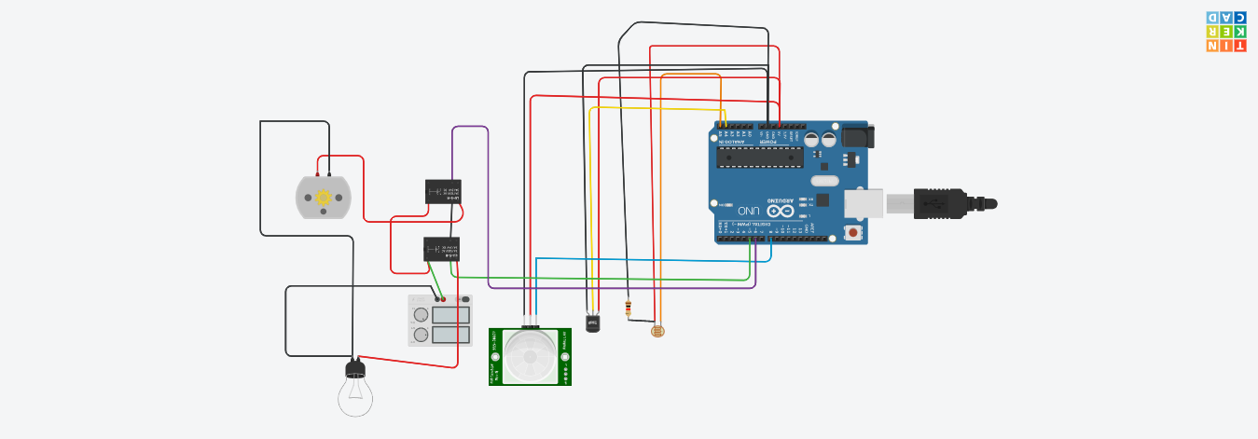

Home automation is building automation for a home called a **smart home** or **smart house**. A home automation system will monitor and/or control home attributes such as lighting, climate, entertainment systems, and appliances. It may also include home security such as access control and alarm systems. When connected with the Internet, home devices are an important constituent of the Internet of Things .

A home automation system typically connects controlled devices to a central smart home hub. The user interface for control of the system uses either wall-mounted terminals, tablet or desktop computers, a mobile phone application, or a Web interface that may also be accessible off-site through the Internet.

The above circuit is done using the arduino board , DC motor, PIR sensor, LED, temperature sensor, relay.

If the temperature increased to a certain level the fan will be on (dc motor), if the brightness of the room is low the ,the LED will be on

**Program:**

|  |
| --- |
| float x,y,z,temp; |
|  | void setup() |
|  | { |
|  | pinMode(8, INPUT); |
|  | pinMode(5, OUTPUT); |
|  | pinMode(6, OUTPUT); |
|  | pinMode(A5, INPUT); |
|  | pinMode(A4, INPUT); |
|  | Serial.begin(9600); |
|  | } |
|  | void loop() |
|  | { |
|  | x= digitalRead(8); |
|  | y= analogRead(A5); |
|  | z= analogRead(A4); |
|  | Serial.println(x); |
|  | Serial.println(y); |
|  | Serial.println(z); |
|  | temp = (double)z / 1024; |
|  | temp = temp * 5; |
|  | temp = temp - 0.5; |
|  | temp = temp * 100; |
|  | if ( (x>0) ) |
|  | { |
|  | if ((y<550)&&(temp>36)) |
|  | { |
|  | digitalWrite(5, HIGH); |
|  | digitalWrite(6, HIGH); |
|  | } |
|  | else if((y<550)&&(temp<36)) |
|  | { |
|  | digitalWrite(5, HIGH); |
|  | digitalWrite(6, LOW); |
|  | } |
|  | else if((y>550)&&(temp>36)) |
|  | { |
|  | digitalWrite(5, LOW); |
|  | digitalWrite(6, HIGH); |
|  | } |
|  | else if((y>550)&&(temp<36)) |
|  | { |
|  | digitalWrite(5, LOW); |
|  | digitalWrite(6, LOW); |
|  | } |
|  | } |
|  | else |
|  | { |
|  | digitalWrite(5, LOW); |
|  | digitalWrite(6, LOW); |
|  | } |
|  | } |

TINKERCAD LINK

<https://www.tinkercad.com/things/3XdmujtIKgw?sharecode=gTMPnqGzQncM6ZKYlUJoUkBhc-2JT3YeYRL6V_QkXkE>